## Real Time/Societal Research Project

## on

“ResumeRole Advisor”

Submitted to the CMR Institute of Technology, Hyderabad in partial fulfillment of the requirement for the award of the Degree of

**II-B.Tech. II -Semester**

**in**

## Computer Science and Engineering (AI&ML)

Submitted by

|  |  |
| --- | --- |
| **B. SAKETH REDDY** | **22R01A66D5** |
| **CH. ARJUN REDDY** | **22R01A66E0** |
| **G. SATHWIKA** | **22R01A66E6** |
| **MD. ARSHAD** | **22R01A66G3** |

Under the Guidance Of

#### Mr. V. Shiva Kumar

(Assistant Professor, Dept of CSE(AI&ML)

# CMR INSTITUTE OF TECHNOLOGY

**(UGC AUTONOMUS)**

**(Approved by AICTE, Affiliated to JNTU, Kukatpally, Hyderabad)**

**Kandlakoya, Medchal Road, Hyderabad**

**2023-2024**

CMR INSTITUTE OF TECHNOLOGY

**(UGC AUTONOMUS)**

**(Approved by AICTE, Affiliated to JNTU, Kukatpally, Hyderabad) Kandlakoya, Medchal Road, Hyderabad.**

## Department of

## Computer Science and Engineering (AI&ML)



**CERTIFICATE**

This is to certify that a Real Time/Societal Research Project entitled with **ResumeRole Advisor** is being

Submitted By

|  |  |
| --- | --- |
| **B. SAKETH REDDY** | **22R01A66D5** |
| **CH. ARJUN REDDY** | **22R01A66E0** |
| **G. SATHWIKA** | **22R01A66E6** |
| **MD. ARSHAD** | **22R01A66G3** |

In partial fulfillment of the requirement for award of the degree of B. Tech in CSE(AI&ML) to the JNTUH, Hyderabad is a record of a bonafide work carried out under our guidance and supervision.

The results in this project have been verified and are found to be satisfactory. The results embodied in this work have not been submitted to have any other University for award of any other degree or diploma

|  |  |  |  |  |
| --- | --- | --- | --- | --- |
| **Signature of Guide** |  | **Signature of Coordinator** |  | **Signature of HOD** |
| Mr. V. Shiva Kumar |  | Dr. S. Rakesh |  | Prof. P. Pavan Kumar |
| **(**Assistant Professor**)** |  | **(**Associate Professor**)** |  | (Head of the Department) |

EXTERNAL EXAMINER

# ACKNOWLEDGEMENT

We are extremely grateful to **Dr. M. Janga Reddy**, **Director**, **Dr. Madhu Sudhana Rao**, **Principal** and **Prof. P. Pavan Kumar**, **Head of Department**, Dept of Computer Science and Engineering (AI&ML), CMR Institute of Technology for their inspiration and valuable guidance during entire duration.

We are extremely thankful to **Dr. S. Rakesh, Real Time/Societal Research Project Coordinator** and internal guide **Mr. V. Shiva Kumar (Assistant Professor)**, Dept of Computer Science and Engineering (AI&ML), CMR Institute of Technology for their constant guidance, encouragement and moral support throughout the project.

We will be failing in duty if we do not acknowledge with grateful thanks to the authors of the references and other literatures referred in this Project.

We express our thanks to all staff members and friends for all the help and coordination extended in bringing out this Project successfully in time.

Finally, we are very much thankful to our parents and relatives who guided directly or indirectly for every step towards success.

|  |  |
| --- | --- |
| **B. SAKETH REDDY** | **22R01A66D5** |
| **CH. ARJUN REDDY** | **22R01A66E0** |
| **G. SATHWIKA** | **22R01A66E6** |
| **MD. ARSHAD** | **22R01A66G3** |

**LIST OF CONTENTS**

|  |  |  |
| --- | --- | --- |
| **1** | **ABSTRACT** | **5** |
| **3** | **INTRODUCTION** | **6** |
| **4** | **LITERATURE SURVEY** | **7-8** |
| **5** | **SYSTEM ANALYSIS** | **9-10** |
|  | 3.1 EXISTING SYSTEM | 9 |
|  | 3.1 DISADVANTAGES OF EXISTING SYSTEM | 9 |
|  | 3.2 PROPOSED SYSTEM | 10 |
|  | 3.2 ADVANTAGES OF PROPOSED SYSTEM | 10 |
| **6** | **REQUIREMENTS** | **11-12** |
|  | 4.1 SOFTWARE REQUIREMENTS | 11 |
|  | 4.2 HARDWARE REQUIREMENTS | 11 |
|  | 4.3 DEPLOYMENT REQUIREMENTS | 11 |
|  | 4.4 MAINTANANCE REQUIREMENTS | 12 |
| **7** | **ARCHITECTURE** | **13** |
| **8** | **BLOCK DIGRAM** | **14** |
| **9** | **IMPLEMENTATION** | **15-21** |
| **10** | **EXPERIMENTAL RESULT** | **22-23** |
| **11** | **CONCLUSION** | **24** |
| **12** | **REFERENCES** | **25** |

**ABSTRACT**

In today’s competitive job market, aligning an individual's skills and experiences with the right job role is crucial for career success. The ResumeRole Finder project aims to enhance this process by utilizing advanced text analysis and machine learning techniques to analyze resumes and recommend suitable job roles. Users can upload their resumes in PDF or TXT formats, and the system processes the content to extract key information about skills, experiences, and qualifications. Based on this extracted data, ResumeRole Finder suggests appropriate job roles that align with the user's profile.

The system employs natural language processing (NLP) to clean and interpret the text within resumes, removing irrelevant information and extracting relevant keywords. It utilizes predefined skill and experience keywords to identify significant information. Machine learning models, specifically trained classification models, then match these skills and experiences with a comprehensive database of job roles.

By providing personalized role recommendations, ResumeRole Finder helps job seekers identify suitable career paths and enhances their prospects of securing roles that best fit their expertise. This project not only aids job seekers in their job search but also assists recruiters in efficiently identifying qualified candidates. Overall, ResumeRole Finder represents a significant advancement in the field of career guidance and recruitment technology.

**INTRODUCTION**

ResumeRole Finder represents a groundbreaking advancement in job application and recruitment technology, designed to revolutionize the process of matching candidates with suitable job roles based on their qualifications and experiences. In today's fiercely competitive job market, where both job seekers and employers face challenges in efficiently navigating through numerous applications and roles, ResumeRole Finder offers a sophisticated solution through the integration of cutting-edge natural language processing (NLP) and machine learning techniques.

The core objective of ResumeRole Finder is to simplify and enhance the job search process for candidates while improving recruitment efficiency for employers. At its heart lies a user-friendly web interface built with Streamlit, enabling candidates to effortlessly upload their resumes in PDF or TXT formats. Once uploaded, the system utilizes advanced NLP algorithms to meticulously extract and clean essential information from the resume text.

The process begins with the extraction of raw text from uploaded resumes, followed by thorough cleaning to remove unnecessary elements such as special characters, URLs, and non-ASCII characters. The cleaned resume text undergoes further analysis using techniques like tokenization to break down text into meaningful units and stop-word removal to filter out common words that do not contribute to the overall meaning.

Overall, ResumeRole Finder aims to empower job seekers in their career pursuits by providing actionable insights into potential job roles that best match their skills and experiences. Simultaneously, it supports employers in making informed hiring decisions by facilitating efficient candidate screening and selection. By leveraging the capabilities of NLP and machine learning, ResumeRole Finder represents a pivotal innovation in enhancing job market dynamics, fostering better career outcomes, and optimizing recruitment processes in today's rapidly evolving employment landscape.

**LITERATURE SURVEY**

Automated systems for resume analysis and job role recommendation have evolved significantly, leveraging various technologies to streamline the recruitment process and enhance candidate-job role alignment. This survey explores key methodologies and advancements in the field:

#### Traditional Resume Screening Methods

Traditional resume screening involves manual review by recruiters, relying on experience and intuition to match candidate qualifications with job requirements. However, this approach is time-consuming, prone to biases, and inefficient for handling large volumes of resumes (Dutta, 2014).

#### Natural Language Processing (NLP) Techniques

NLP plays a pivotal role in automating resume analysis by extracting and interpreting textual information. Techniques such as named entity recognition (NER), sentiment analysis, and keyword extraction enable systems to identify key skills, experiences, and qualifications from resumes (Manning et al., 2008).

#### Machine Learning Models for Classification

Machine learning models, including support vector machines (SVM), decision trees, and neural networks, are applied to classify resumes into job-relevant categories based on extracted features. These models learn from labeled data to predict job suitability and match candidates to appropriate roles.

#### Semantic Matching and Recommendation Systems

Semantic matching techniques use semantic analysis to match candidate profiles with job descriptions based on similarity measures. Systems like those described by Huang et al. (2018) employ semantic embeddings and ontologies to enhance the accuracy of job role recommendations.

#### Deep Learning Approaches

Recent advancements in deep learning have revolutionized resume analysis and job role recommendation. Deep neural networks, such as convolutional neural networks (CNNs) and recurrent neural networks (RNNs), enable systems to capture complex patterns in resumes and job descriptions, improving matching accuracy (LeCun et al., 2015).

#### Commercial Applicant Tracking Systems (ATS)

ATS platforms like Taleo, Greenhouse, and Workday utilize advanced algorithms and user-friendly interfaces to automate resume screening and job role matching. These systems integrate NLP, machine learning, and semantic technologies to streamline recruitment processes (Dwivedi et al., 2017).

1. **Conclusion**

The evolution of automated resume analysis and job role recommendation systems reflects ongoing efforts to enhance recruitment efficiency and candidate-job fit. From traditional methods to cutting-edge AI and deep learning techniques, this literature survey highlights the diverse approaches contributing to the development of ResumeRole Finder. By integrating advanced algorithms and user-friendly interfaces, this project aims to deliver a robust solution for optimizing the recruitment process in modern organizations.

This structured literature survey provides a comprehensive overview of methodologies and advancements in automated resume analysis and job role recommendation systems, highlighting their significance in modern recruitment practices and setting the stage for the development of ResumeRole Finder.

**SYSTEM ANALYSIS**

**Existing System**

The existing system for resume screening and job role recommendation predominantly relies on manual methods and basic applicant tracking systems (ATS). Recruiters manually review resumes, which is time-consuming and prone to biases. ATS systems, while automating some aspects of resume parsing, often lack advanced capabilities in semantic analysis and personalized job role matching. These systems typically rely on keyword matching and basic classification models, which may lead to mismatches between candidate qualifications and job requirements.

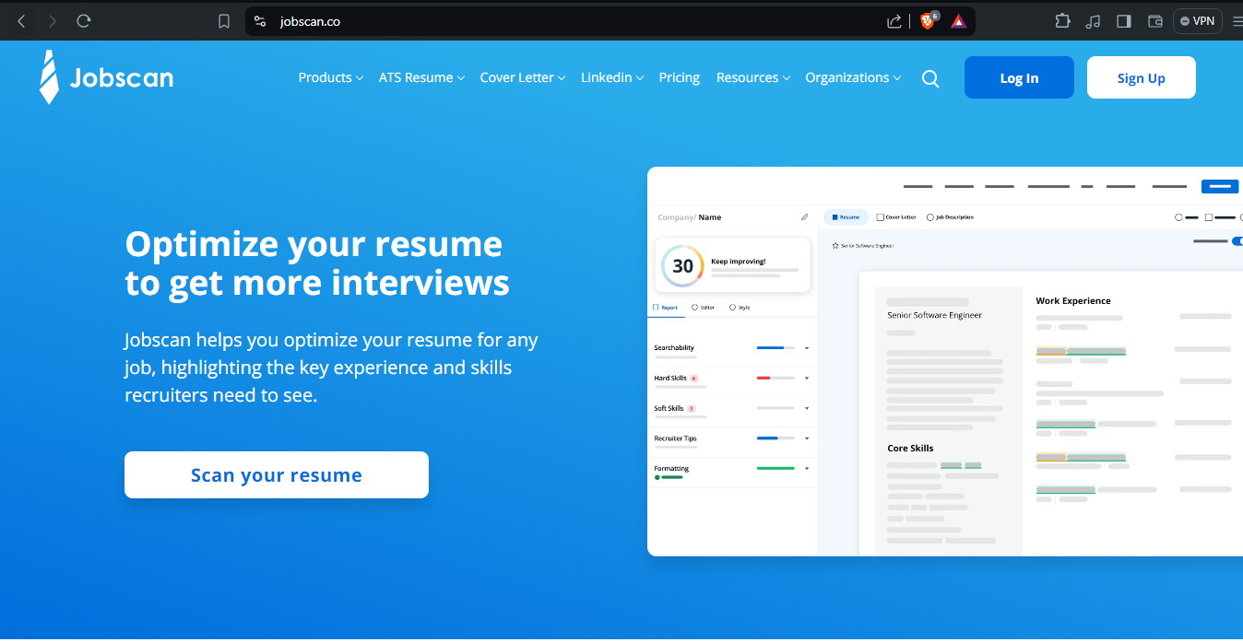

**Disadvantages of Existing System**

1. **Time-Consuming**: Manual resume screening is labor-intensive and slows down the recruitment process.

1. **Bias and Inconsistency**: Human judgment in resume evaluation can introduce biases based on subjective criteria.
2. **Limited Automation**: Basic ATS systems may struggle with complex resumes or non-standard formats, leading to incomplete or inaccurate data extraction.
3. **Keyword-Based Matching**: Reliance on keywords for matching candidates to job roles may overlook contextual relevance and nuanced qualifications.

**Proposed System**

The **ResumeRole Finder** project proposes an advanced automated system for resume analysis and job role recommendation using cutting-edge technologies such as natural language processing (NLP), machine learning (ML), and semantic matching algorithms.

**Advantages of Proposed System**

1. **Automated Resume Analysis**: Utilizes NLP techniques to extract and analyze key information from resumes, including skills, experiences, and qualifications.
2. **Advanced Classification Models**: Employs machine learning models to classify resumes into relevant job categories based on extracted features, improving accuracy and efficiency.
3. **Semantic Matching**: Integrates semantic analysis to match candidate profiles with job descriptions based on contextual relevance, enhancing job-role fit.
4. **Personalized Recommendations**: Provides personalized job role recommendations based on comprehensive analysis of candidate profiles and job requirements.
5. **Reduced Bias**: Minimizes bias in candidate selection by using objective criteria and standardized evaluation metrics.
6. **Efficiency and Scalability**: Streamlines the recruitment process, reducing time-to-hire and enabling handling of large volumes of resumes effectively.

**REQUIREMENTS**

**SOFTWARE REQUIREMENTS**

1. **Operating System**: The system should be compatible with major operating systems such as Windows, macOS, and Linux.
2. **Programming Languages and Frameworks**:
   1. Python for backend development and scripting.
   2. Streamlit or Flask for building the web application interface.
   3. Libraries such as NLTK, Scikit-learn, PyPDF2 for natural language processing and machine learning tasks.
3. **Database Management System**: SQLite or MySQL for storing user data, resumes, and job role recommendations.
4. **Version Control**: Git for version control and collaboration among developers.
5. **Development Environment**: Integrated Development Environment (IDE) such as PyCharm, VS Code, or Jupyter Notebook for coding and debugging.
6. **Web Hosting**: Platform-as-a-Service (PaaS) provider like Heroku or AWS Elastic Beanstalk for hosting the web application.

**HARDWARE REQUIREMENTS**

1. **Processor**: Multi-core processor (e.g., Intel Core i5 or AMD Ryzen 5) for efficient data processing.
2. **Memory**: Minimum 8GB RAM to handle large datasets and concurrent user sessions.
3. **Storage**: SSD storage for faster data access and retrieval.

**DEPLOYMENT REQUIREMENTS**

1. **Web Server**: Deployment on a reliable web server capable of handling concurrent user requests, such as Nginx or Apache.
2. **Cloud Infrastructure**: Utilize cloud services (e.g., AWS EC2 instances) for scalable performance and resource management.
3. **Security**:
   * 1. Implement HTTPS protocol and SSL certificates to ensure secure data transmission.
     2. Use firewalls and access controls to protect the application from unauthorized access.
4. **Backup and Recovery**:
   * 1. Regularly backup application data and configurations to prevent data loss.
     2. Implement disaster recovery procedures to restore the application in case of failures.

**MAINTENANCE REQUIREMENTS**

1. **Monitoring and Logging**:
   * 1. Set up monitoring tools (e.g., Prometheus, Grafana) to track application performance metrics and user interactions.
     2. Implement logging mechanisms (e.g., ELK stack) to capture and analyze system logs for debugging and optimization.
2. **Software Updates**: Regularly update software dependencies and libraries to maintain compatibility and security patches.
3. **User Support and Training**:
   * 1. Provide user support through documentation, FAQs, and a helpdesk for addressing user queries and issues.
     2. Conduct training sessions for administrators and users on using the system effectively.
4. **Performance Optimization**:
   * 1. Conduct performance testing and optimization to ensure the system can handle peak loads efficiently.
     2. Implement caching mechanisms (e.g., Redis) to improve response times for frequently accessed data.
5. **Compliance and Regulations**: Ensure compliance with data protection regulations (e.g., GDPR, HIPAA) when handling user data and resumes.

**ARCHITECTURE**



Upload pdf or txt file



Text extracting & cleaning



Skill and Experience Extraction



Preprocessing & Classification



Result Display (with skills)

**BLOCK DIAGRAM**

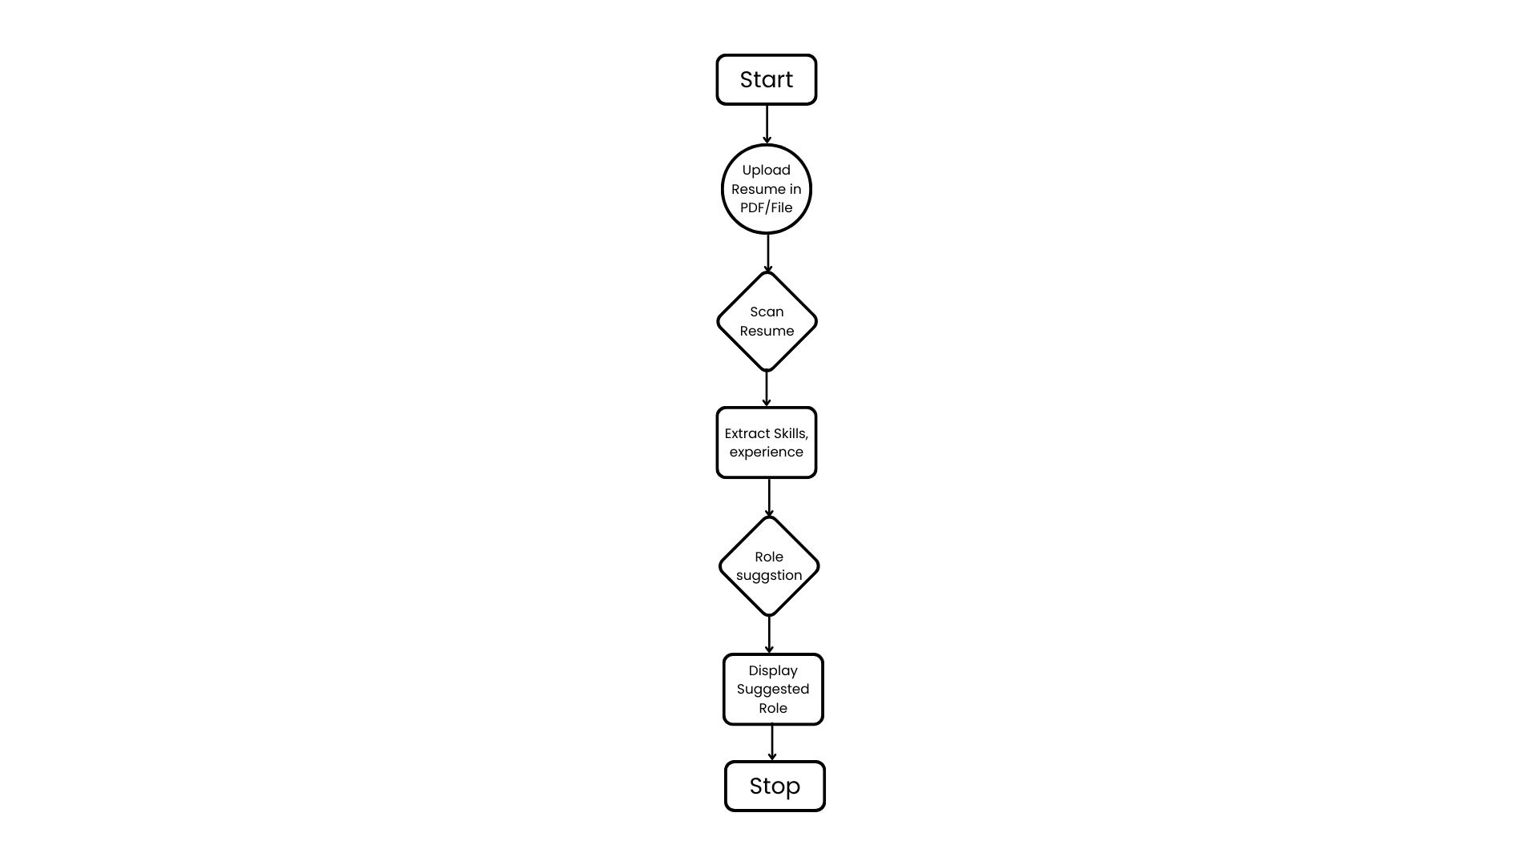

**IMPLEMENTATION**

**SOURCE CODE**:

**app.py**

import streamlit as st

import pickle

import re

import nltk

from PyPDF2 import PdfReader

nltk.download('punkt')

nltk.download('stopwords')

clf = pickle.load(open('clf.pkl', 'rb'))

tfidf = pickle.load(open('tfidf.pkl', 'rb'))

def clean_resume(resume_text):

"""

Function to clean resume text by removing URLs, special characters, etc.

"""

clean_text = re.sub('http\S+\s*', ' ', resume_text)

clean_text = re.sub('RT|cc', ' ', clean_text)

clean_text = re.sub('#\S+', '', clean_text)

clean_text = re.sub('@\S+', ' ', clean_text)

clean_text = re.sub('[%s]' % re.escape("""!"#$%&'()*+,-./:;<=>?@[\]^_`{|}~"""), ' ', clean_text)

clean_text = re.sub(r'[^\x00-\x7f]', r' ', clean_text)

clean_text = re.sub('\s+', ' ', clean_text)

return clean_text

def extract_text_from_pdf(uploaded_file):

"""

Function to extract text from a PDF file

"""

pdf_reader = PdfReader(uploaded_file)

text = ""

for page in pdf_reader.pages:

text += page.extract_text()

return text

def extract_skills_and_experience(text):

"""

Function to extract skills and experience from resume text

"""

skills_keywords = ['Python', 'Java', 'C++', 'SQL', 'JavaScript', 'AWS', 'Azure', 'Docker', 'Kubernetes', 'Machine Learning', 'Deep Learning', 'AI', 'Data Science', 'DevOps', 'Web Development', 'React', 'Angular', 'Django', 'Flask']

experience_keywords = ['experience', 'worked', 'developed', 'managed', 'led', 'designed']

skills = [skill for skill in skills_keywords if re.search(r'\b' + re.escape(skill) + r'\b', text, re.IGNORECASE)]

experience = [exp for exp in experience_keywords if re.search(r'\b' + re.escape(exp) + r'\b', text, re.IGNORECASE)]

return skills, experience

def main():

"""

Main function to run the Streamlit web app

"""

st.title("Resume Screening App")

uploaded_file = st.file_uploader('Upload Resume', type=['txt', 'pdf'])

if uploaded_file is not None:

if uploaded_file.type == "application/pdf":

resume_text = extract_text_from_pdf(uploaded_file)

else:

resume_bytes = uploaded_file.read()

try:

resume_text = resume_bytes.decode('utf-8')

except UnicodeDecodeError:

resume_text = resume_bytes.decode('latin-1')

cleaned_resume = clean_resume(resume_text)

skills, experience = extract_skills_and_experience(cleaned_resume)

st.write("Extracted Skills:", skills)

st.write("Extracted Experience Keywords:", experience)

enriched_resume = " ".join(skills + experience) + " " + cleaned_resume

input_features = tfidf.transform([enriched_resume])

prediction_id = clf.predict(input_features)[0]

category_mapping = {

2: "Automation Testing",

3: "Blockchain",

4: "Business Analyst",

5: "Civil Engineer",

6: "Data Science",

7: "Database",

8: "DevOps Engineer",

9: "DotNet Developer",

10: "ETL Developer",

11: "Electrical Engineer",

13: "Hadoop",

15: "Java Developer",

16: "Mechanical Engineer",

17: "Network Security Engineer",

18: "Operations Manager",

19: "PMO",

20: "Python Developer",

21: "SAP Developer",

23: "Testing",

24: "Web Designing",

25: "Web Developer",

26: "AI Engineer",

}

category_name = category_mapping.get(prediction_id, "Unknown")

st.write("Predicted Category:", category_name)

if __name__ == "__main__":

main()

**Resume Screening with Python.ipynb**

import numpy as np

import pandas as pd

import matplotlib.pyplot as plt

import seaborn as sns

df = pd.read_csv('UpdatedResumeDataSet.csv')

df.head()

df.shape

# Exploring Categories

df['Category'].value_counts()

plt.figure(figsize=(15,5))

sns.countplot(df['Category'])

plt.xticks(rotation=90)

plt.show()

df['Category'].unique()

counts = df['Category'].value_counts()

labels = df['Category'].unique()

plt.figure(figsize=(15,10))

plt.pie(counts,labels=labels,autopct='%1.1f%%',shadow=True, colors=plt.cm.plasma(np.linspace(0,1,3)))

plt.show()

# Exploring Resume

df['Category'][0]

df['Resume'][0]

# Cleaning Data:

1 URLs,

2 hashtags,

3 mentions,

4 special letters,

5 punctuations:

import re

def cleanResume(txt):

cleanText = re.sub('http\S+\s', ' ', txt)

cleanText = re.sub('RT|cc', ' ', cleanText)

cleanText = re.sub('#\S+\s', ' ', cleanText)

cleanText = re.sub('@\S+', ' ', cleanText)

cleanText = re.sub('[%s]' % re.escape("""!"#$%&'()*+,-./:;<=>?@[\]^_`{|}~"""), ' ', cleanText)

cleanText = re.sub(r'[^\x00-\x7f]', ' ', cleanText)

cleanText = re.sub('\s+', ' ', cleanText)

return cleanText

cleanResume("my #### $ # #noorsaeed webiste like is this http://heloword and access it @gmain.com")

df['Resume'] = df['Resume'].apply(lambda x: cleanResume(x))

df['Resume'][0]

# words into categorical values

from sklearn.preprocessing import LabelEncoder

le = LabelEncoder()

le.fit(df['Category'])

df['Category'] = le.transform(df['Category'])

df.Category.unique()

# ['Data Science', 'HR', 'Advocate', 'Arts', 'Web Designing',

# 'Mechanical Engineer', 'Sales', 'Health and fitness',

# 'Civil Engineer', 'Java Developer', 'Business Analyst',

# 'SAP Developer', 'Automation Testing', 'Electrical Engineering',

# 'Operations Manager', 'Python Developer', 'DevOps Engineer',

# 'Network Security Engineer', 'PMO', 'Database', 'Hadoop',

# 'ETL Developer', 'DotNet Developer', 'Blockchain', 'Testing'],

# dtype=object)

# Vactorization

from sklearn.feature_extraction.text import TfidfVectorizer

tfidf = TfidfVectorizer(stop_words='english')

tfidf.fit(df['Resume'])

requredTaxt = tfidf.transform(df['Resume'])

# Splitting

from sklearn.model_selection import train_test_split

X_train, X_test, y_train, y_test = train_test_split(requredTaxt, df['Category'], test_size=0.2, random_state=42)

X_train.shape

X_test.shape

# Now let’s train the model and print the classification report:

from sklearn.neighbors import KNeighborsClassifier

from sklearn.multiclass import OneVsRestClassifier

from sklearn.metrics import accuracy_score

clf = OneVsRestClassifier(KNeighborsClassifier())

clf.fit(X_train,y_train)

ypred = clf.predict(X_test)

print(accuracy_score(y_test,ypred))

ypred

# Prediction System

import pickle

pickle.dump(tfidf,open('tfidf.pkl','wb'))

pickle.dump(clf, open('clf.pkl', 'wb'))

myresume = """I am a data scientist specializing in machine

learning, deep learning, and computer vision. With

a strong background in mathematics, statistics,

and programming, I am passionate about

uncovering hidden patterns and insights in data.

I have extensive experience in developing

predictive models, implementing deep learning

algorithms, and designing computer vision

systems. My technical skills include proficiency in

Python, Sklearn, TensorFlow, and PyTorch.

What sets me apart is my ability to effectively

communicate complex concepts to diverse

audiences. I excel in translating technical insights

into actionable recommendations that drive

informed decision-making.

If you're looking for a dedicated and versatile data

scientist to collaborate on impactful projects, I am

eager to contribute my expertise. Let's harness the

power of data together to unlock new possibilities

and shape a better future.

Contact & Sources

Email: 611noorsaeed@gmail.com

Phone: 03442826192

Github: https://github.com/611noorsaeed

Linkdin: https://www.linkedin.com/in/noor-saeed654a23263/

Blogs: https://medium.com/@611noorsaeed

Youtube: Artificial Intelligence

ABOUT ME

WORK EXPERIENCE

SKILLES

NOOR SAEED

LANGUAGES

English

Urdu

Hindi

I am a versatile data scientist with expertise in a wide

range of projects, including machine learning,

recommendation systems, deep learning, and computer

vision. Throughout my career, I have successfully

developed and deployed various machine learning models

to solve complex problems and drive data-driven

decision-making

Machine Learnine

Deep Learning

Computer Vision

Recommendation Systems

Data Visualization

Programming Languages (Python, SQL)

Data Preprocessing and Feature Engineering

Model Evaluation and Deployment

Statistical Analysis

Communication and Collaboration

"""

import pickle

# Load the trained classifier

clf = pickle.load(open('clf.pkl', 'rb'))

# Clean the input resume

cleaned_resume = cleanResume(myresume)

# Transform the cleaned resume using the trained TfidfVectorizer

input_features = tfidf.transform([cleaned_resume])

# Make the prediction using the loaded classifier

prediction_id = clf.predict(input_features)[0]

# Map category ID to category name

category_mapping = {

15: "Java Developer",

23: "Testing",

8: "DevOps Engineer",

20: "Python Developer",

24: "Web Designing",

12: "HR",

13: "Hadoop",

3: "Blockchain",

10: "ETL Developer",

18: "Operations Manager",

6: "Data Science",

22: "Sales",

16: "Mechanical Engineer",

1: "Arts",

7: "Database",

11: "Electrical Engineering",

14: "Health and fitness",

19: "PMO",

4: "Business Analyst",

9: "DotNet Developer",

2: "Automation Testing",

17: "Network Security Engineer",

21: "SAP Developer",

5: "Civil Engineer",

0: "Advocate",

}

category_name = category_mapping.get(prediction_id, "Unknown")

print("Predicted Category:", category_name)

print(prediction_id)

**RESULT**

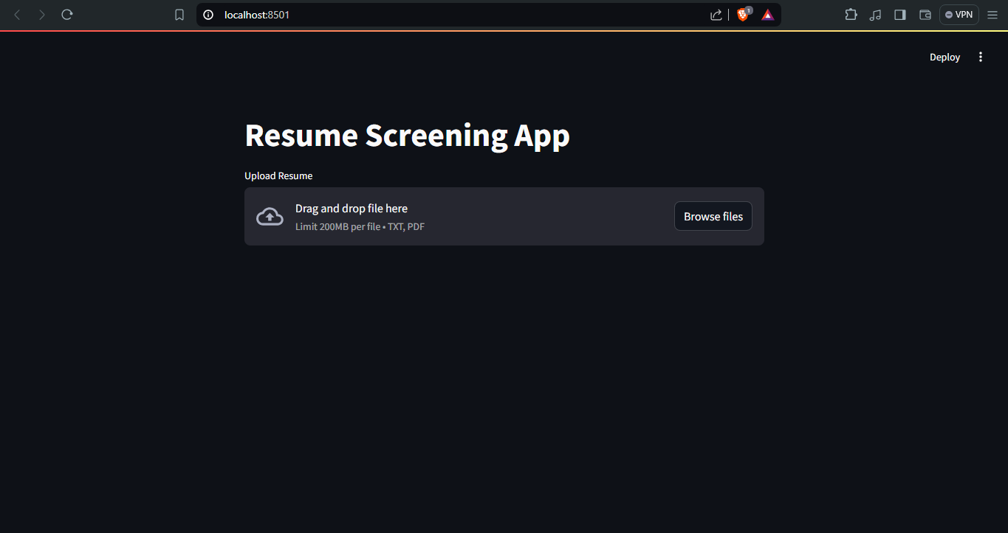

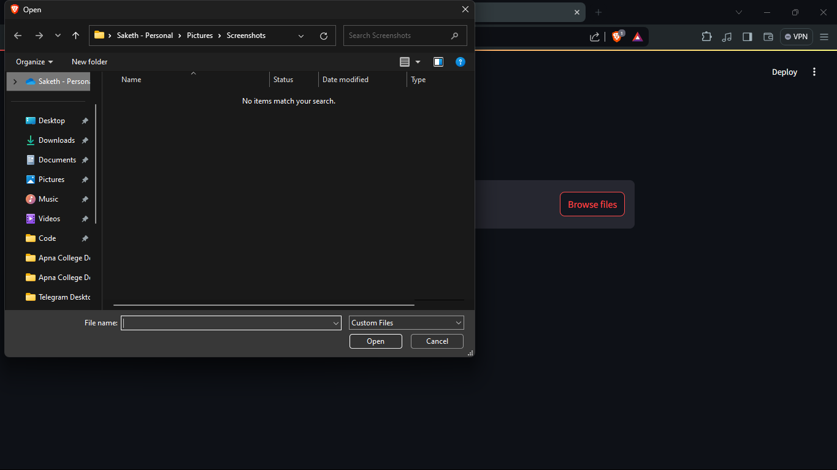

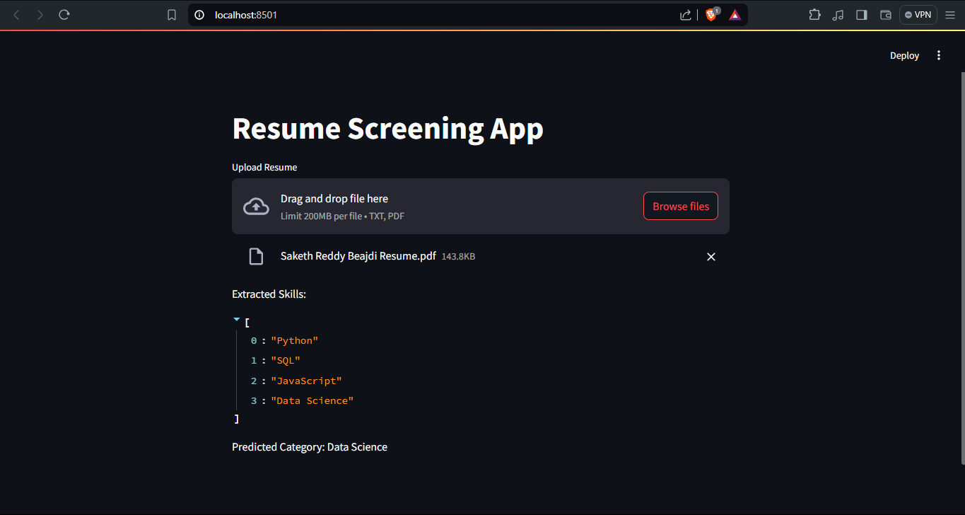

**CONCLUSION**

The **ResumeRole Finder** project introduces a sophisticated solution for automating resume analysis and job role recommendation, leveraging state-of-the-art technologies such as natural language processing (NLP) and machine learning (ML). This initiative aims to streamline the recruitment process by automating the extraction of key information from resumes, including skills, experiences, and qualifications. By eliminating manual effort in resume screening, the system enhances efficiency and reduces bias, thereby accelerating the candidate selection process for recruiters.

Furthermore, the project's integration of advanced ML models ensures accurate classification of resumes into relevant job categories and semantic matching with job descriptions. This capability not only enhances the precision of job role recommendations but also personalizes the job-seeking experience for candidates. The user-friendly interface, powered by Streamlit, facilitates seamless interaction where users can upload resumes, view extracted insights, and receive tailored job role suggestions intuitively.

Deployed on scalable cloud infrastructure, **ResumeRole Finder** ensures robust performance to handle large volumes of resumes and concurrent user interactions effectively. This scalability, coupled with performance optimization techniques like caching and data management, reinforces the system's reliability in real-world recruitment scenarios.

Looking ahead, the project's future enhancements could include integrating deeper AI capabilities such as deep learning for enhanced resume parsing and reinforcement learning for adaptive job role recommendations. Additionally, further integration with existing HR systems and ATS platforms would extend its utility across diverse organizational settings, fostering a more integrated approach to talent acquisition and management.

In conclusion, **ResumeRole Finder** not only addresses current challenges in recruitment but also sets a precedent for innovation in leveraging AI-driven technologies to reshape how organizations identify and engage with talent. By continuously refining its capabilities and ensuring compliance with data protection standards, the project aims to contribute significantly to advancing workforce management practices and promoting a more efficient and inclusive job market.

**REFERENCES**

1. **Kronos Scheduling Software**: A commercial software solution for scheduling and workforce management Website: [Kronos](https://www.kronos.com)
2. **PyPDF2 Documentation**: Python library for reading and manipulating PDF files. Website: PyPDF2 Documentation
3. **Streamlit Documentation**: Official documentation for Streamlit, a popular framework for building interactive web applications with Python. Website: Streamlit Documentation
4. **NLTK Documentation**: Natural Language Toolkit (NLTK) documentation for text processing and NLP tasks in Python. Website: [NLTK Documentation](https://www.nltk.org/)
5. **Scikit-learn Documentation**: Documentation for Scikit-learn, a machine learning library for Python. Website: Scikit-learn Documentation
6. **MySQL Documentation**: Official documentation for MySQL, a popular open-source relational database management system. Website: [MySQL Documentation](https://dev.mysql.com/doc/)
7. **SQLite Documentation**: Official documentation for SQLite, a lightweight SQL database engine. Website: SQLite Documentation
8. **Git Documentation**: Official documentation for Git version control system. Website: [Git Documentation](https://git-scm.com/doc)
9. **Heroku Documentation**: Documentation for Heroku, a cloud platform for deploying, managing, and scaling applications. Website: Heroku Documentation
10. **GitHub**: Platform for hosting Git repositories and collaborative development. Website: [GitHub](https://github.com/)
11. **IEEE Xplore**: IEEE Xplore Digital Library provides access to journals, conference proceedings, and standards in engineering and technology. Website: [IEEE Xplore](https://ieeexplore.ieee.org/Xplore/home.jsp)